CIS 195 Extra Credit Assignment

Mimic a Portion of the Five Talent Webpage  
40 Points

# Objective

You’ll be making a mock-up (clone) of a portion of the web site at <https://www.fivetalent.com/>. However, you should rely heavily on the photo and bullet points of criteria. I learned, just before writing these directions, that FiveTalent will be introducing a new website this afternoon.

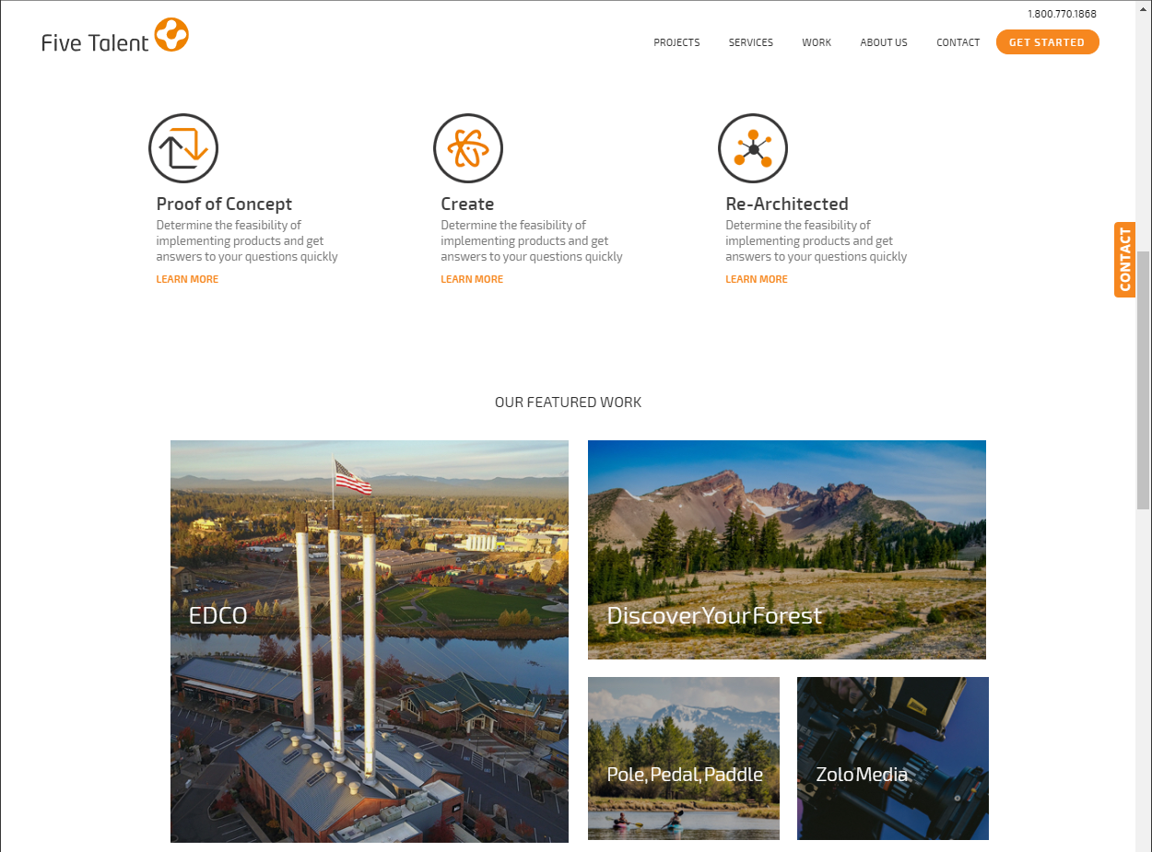

I’m only asking you to mimic the visible portion shown above. I zoomed out on the browser to fit in some elements, otherwise, it lines up neatly on the left and right sides underneath the Five Talent logo and the Get Started call-to-action.

# Top Section

For the top section, you’ll produce the look/layout and menu items shown. You can find a current logo on their website (perhaps an svg version) or grab the png version at <http://ralph18fall.cocc-cis.com/images/fivetalentlogo.png>.

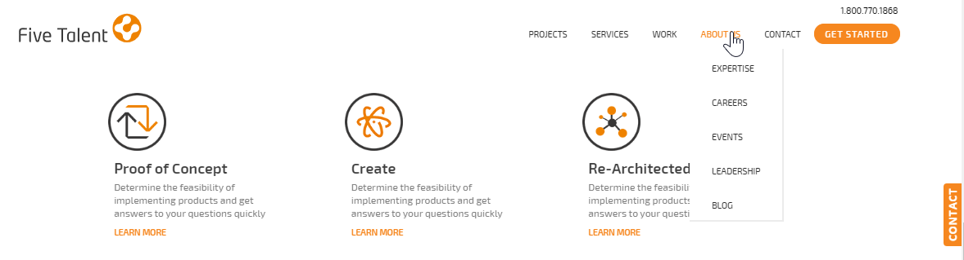

* The logo is a hyperlink to the website home page
* The navigation menu offers drop-down options. Use dummy links, but use realistic wording and options. The menu on the real website may look different than my picture, but I imagine their menu options will be the same (or very similar).
* All five menu options of a submenu/drop-down of choices.
* The “Get Started” call-to-action is styled with a slight darkening of the orange color on hover.
* The phone number in the very top right is a telephone hyperlink.
* The contact button along the right is fixed, and stays fixed on scroll.
* The three anchors just below the menu are large blocks, side-by-side. They also have a slight hover effect, like the picture below.

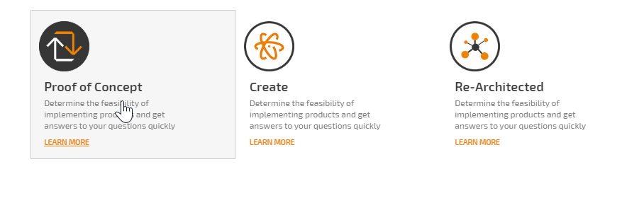

# Bottom/Main Section

For this part, you’re working on the “Our Featured Work” area. You can use flexbox or grid for this, but each of these blocks are hyperlinks with an interesting hover effect.

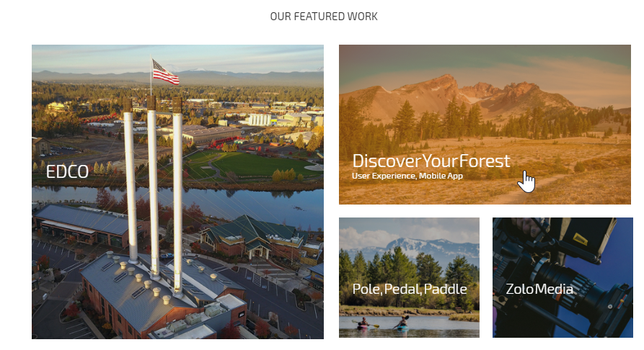

* The background images re-sizes/zooms out a bit, showing more background image
* The background images gets an “orange filter”
* The anchor text shifts up a bit, and some sub-title text appears.

# HTML Quiz (10 Points)

In addition to making the mock-up page described above, head over to<https://www.w3schools.com/html/html_quiz.asp> and take their 40-question HTML quiz. If there are questions you don’t know the answer to, look them up.

* Goal for the full 10 points is to **Score at least 35/40 within 40 minutes.** Send a screen capture of your results to Ralph at rrphillips@cocc.edu. Take the quiz as many times as you like, to get the top score and the XC.

